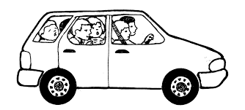

Summerfield Elementary School
Student Permanent Transportation Change

Student name (last name first): ____________________________________

Student’s teacher and grade: ______________________________________

Begnning on ___________________________, the above student will:
(Date)

_______ be a car rider

_______ be a bus rider on bus # ________

_______ go home via car rider with _______________________________

_______ go home via bus with with ___________________ on bus # ____

_______ other ________________________________________________

This change will be effective for the remainder of the school year.

Signature of parent/ guardian _______________________________

Contact phone number _______________________________

